Animation Request Document

This Document includes any Concept Art, Mood Boards and Animation Trees relevant to the required Model and Animations

Contents

Model: Main Character 1

Concepts 1

Character Concepts: 1

Kopis Concepts: 1

Spear Concepts: 1

Shield Concepts: 1

Character Animation Trees: 2

Spear: 2

Sword: 2

Bow 3

# Model: Main Character

Description: A Male of athletic build from Ancient Greece dressed fully in armour, the character will always be wearing a helmet and therefore facial features aren’t not a crucial aspect of the model. The Character will wield a spear as the main weapon, a Bow, a Kopis Blade as a side arm and a circular shield (all of which are pictured in the images below)

# Concepts

## Character Concepts:

## Kopis Concepts:

## Spear Concepts:

## Shield Concepts:

# Character Animation Trees:

Spear:  
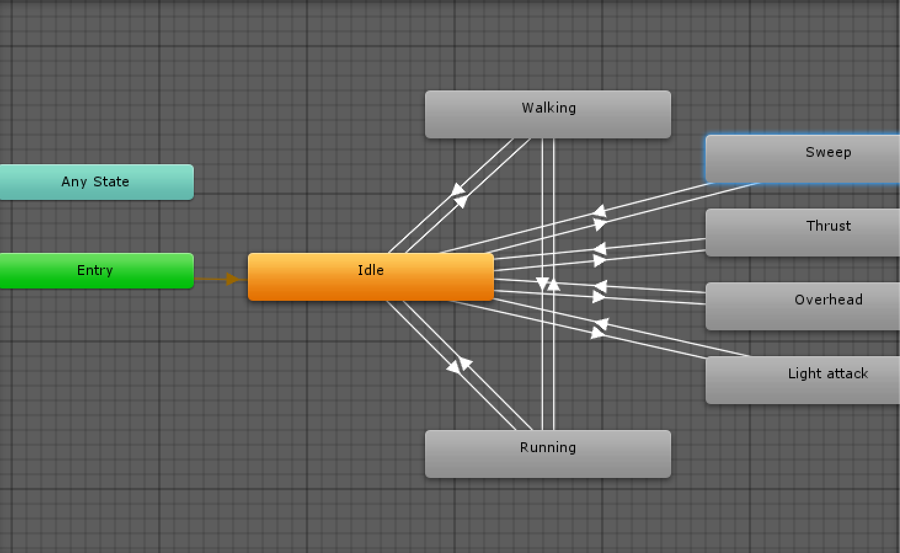

## Sword:

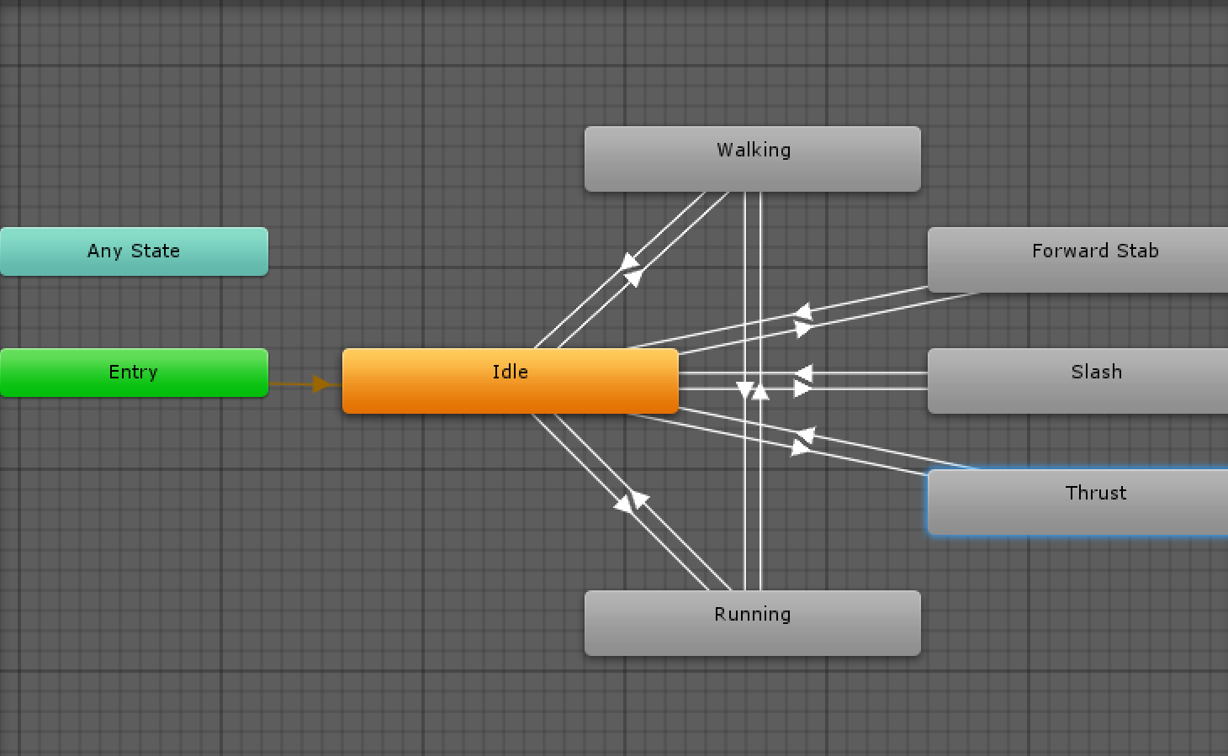

## Bow

